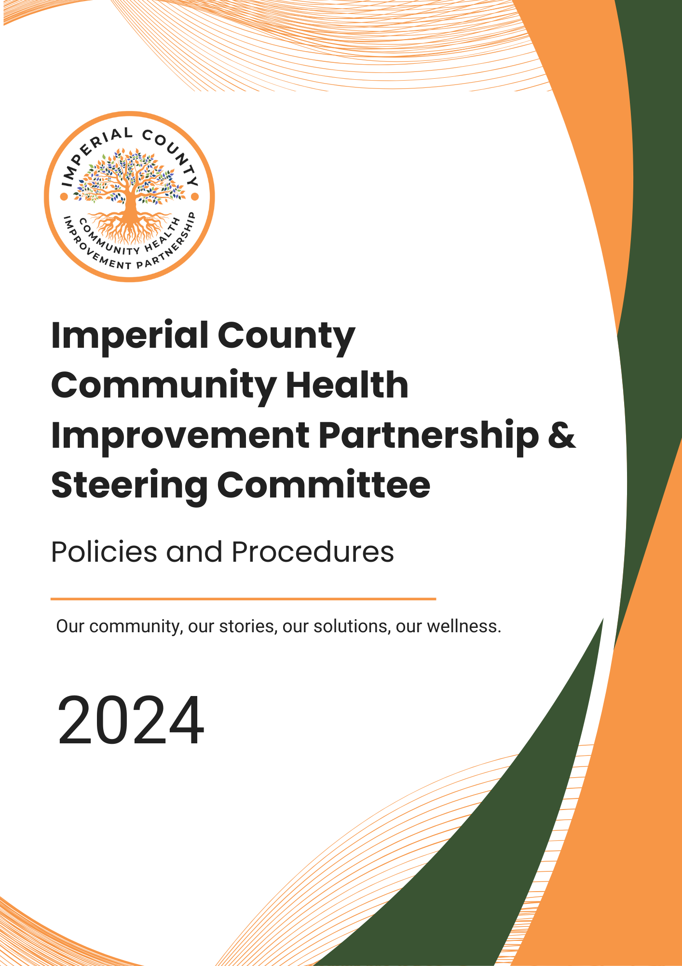

**Table of Contents**

I. Policies and Procedures 1

II. Revisions and Maintenance 1

III. Background 1

Purpose 1

Ownership 1

Adoption Process 2

About the ICCHIP Structure 2

IV. Community Partnership 3

Purpose 3

Partners 3

Rolesand Responsibilities 3

Collaboration & Data Sharing 3

OperationalProcedures 4

V. Steering Committee 4

Purpose 4

Membership 4

MemberRoles and Responsibilities 4

Qualifications 4

Selection Process 4

Chair & Vice-Chair Roles and Responsibilities 4

Decision-Making & Escalation Pathways 4

OperationalProcedures 5

VI. Priority Areas Workgroups 5

Purpose 5

Rolesand Responsibilities 5

MembershipSelection 5

Leadership (Co-lead) 5

OperationalProcedures 5

VII. Sub-Committee Workgroups 6

Membership 6

Sub-Committees 6

Member Responsibilities 6

VIII. NCE Staff 6

Roles & Responsibilities 6

OperationalOversight 7

CurrentContact 7

IX. Communication 7

In-person Meetings and Virtual Meetings 7

Emailand Digital Communication Platform 7

CommunityPartnership 7

CommunityOrganizations/Potential Partners 7

NCEStaf**f** 7

Version History 8

Approval History 8

# **I. Policies and Procedures**

## **Purpose**

This document establishes policies and procedures that govern:

* Community Health Assessment (CHA) and Community Health Improvement Plan (CHIP)
* Imperial County Community Health Improvement Partnership (ICCHIP)
* Steering Committee
* Priority Area Workgroups
* Sub-Committees Workgroups
* Neutral Coordinating Entity (NCE)

# **II. Revisions and Maintenance**

Policies and procedures will be reviewed annually.

* The Steering Committee Chair and/or Vice Chair will lead the review process.
* Any revisions will be discussed during a Steering Committee meeting, with feedback incorporated accordingly.
* If no changes are required, documentation will be maintained as a record.
* Revised policies will be posted within 10 business days for public access.

# **III. Background**

The Community Health Assessment (CHA) and Community Health Improvement Plan (CHIP) process was initiated in June 2022 to assess community health needs and develop targeted solutions.

## **Purpose**

To systematically identify and address community health priorities.

**Ownership**

The CHA/CHIP belongs to all community stakeholders, including local agencies, organizations, and residents.

**Adoption Process**

All participating entities are encouraged to share and implement the CHA/CHIP action plan. As part of adopting the CHA/CHIP, entities may add the CHA/CHIP website link to their website.

### 

### **Vision**

Our vision is to build upon a community that is rich in connection, culture, and resiliency to

realize a healthy, empowered, and thriving Imperial County.

**Mission**

### Our mission is to uplift the well-being of our diverse community through collective efforts

### centered in integrity, transparency, and strategic action to realize health equity and the

### empowerment of every individual.

### **Values**

|  |  |  |
| --- | --- | --- |
| Sustainability | Innovation | Collaborative |
| Respect | Equity | Transparent |
| Community Focused | | |

**About the ICCHIP structure:** The partnership structure is built around the community’s needs, ensuring that every decision and action is driven by their priorities. This collaborative framework aligns our Steering Committee, Stakeholders, Priority Area Workgroups, and Backbone operations with ongoing community feedback, making the community not just a focus, but a core element of our strategy. This approach ensures that each decision fosters growth, well-being, and empowerment.

* **Community**: Driven by the community, it is essential in the decision-making, engagement, and success of the CHA/CHIP process.
* **Priority Areas**: Focus on Access to High-Quality Healthcare, Healthy and safeLiving, and Behavioral Health.
* **Stakeholders & Steering Committee**: Work collaboratively to manage initiatives and make key decisions.
* **Backbone (Imperial County Public Health)**: This entity facilitates operations as the Neutral Coordinating Entity (NCE).

# 

# **IV. Community Partnership**

**Purpose**

The ICCHIP consists of individuals and organizations working collaboratively to improve health outcomes.

**Partners**

Any individual or organization can become a partner by submitting an **ICCHIP Interest Form** for review.

**Roles and Responsibilities**

* Attend community meetings and activities
* Stay informed through meeting notes and reports
* Disseminate CHA/CHIP updates within their respective organizations
* Participating in workgroups and advisory committees

**Collaboration & Data Sharing**

In alignment with the partnership’s commitment to collaboration and continuous improvement, all members are encouraged to actively participate in data collection efforts related to the partnership's goals. This may involve engaging in data collection activities, including but not limited to sharing available data from their respective agencies, surveys, assessments, and other data-driven initiatives.  While participation is voluntary, sharing data will help ensure a coordinated approach to addressing community health needs, strengthen collective outcomes, and enhance the impact of the partnership’s work.

**Operational Procedures**

* **Meetings:** Held **quarterly** (dates announced online and via email)
* **Meeting Notes:** Available on the ICCHIP website within **5 business days**
* **Community Forums:** Held **bi-annually** for direct public engagement

# **V. Steering Committee**

**Purpose**

The Steering Committee ensures progress and accountability for CHA/CHIP initiatives.

**Membership**

* Maximum **15** members
* Members represent various sectors
* Ex officio members include

|  |
| --- |
| * Behavioral Health |
| * California Health & Wellness | Health Net |
| * Community Health Plan of Imperial Valley |
| * El Centro Regional Medical Center |
| * Imperial County America’s Job Center of California |
| * Imperial County First 5 |
| * Imperial County Office of Education |
| * Imperial County Public Health Department (ICPHD) |
| * Imperial Valley Coalition for Sustainable Healthcare Facilities |
| * Innercare |
| * Kaiser Permanente |
| * San Diego State University |
| * San Diego State University, Imperial Valley School of Nursing |
| * Westmorland Pantry |

**Member Roles and Responsibilities**

* Attend at least **75% of meetings annually**
* Engage in decision-making and workgroup activities
* Leverage resources to support CHIP efforts
* Approve and monitor the progress of CHA/CHIP efforts and the established action plans.

**Qualifications**

* Decision-making authority within their organization
* Commitment to community health initiatives
* Strong knowledge of local health and social issues

**Selection Process**

* Openings announced via email & website
* Interested individuals must submit an **Application Form**
* Steering Committee votes for new members

**Chair & Vice-Chair Roles and Responsibilities**

* **Chair:** Leads meetings, represents the committee, monitors progress
* **Vice-Chair:** Supports Chair, steps in as needed
* **Election:** Candidates are nominated and selected via majority vote
* **Terms:** Two-year term,renewable once
* **Documentation:** Finalize the agendas, with the assistance of NCE staff, at least 1 week before the upcoming Community Partnership meeting.
* **Meetings:** Facilitates the Steering Committee and Community Partnership meetings.

**Decision-Making & Escalation Pathways**

* Decisions require a quorum to be presentin person or virtually.
* If conflicts arise, an issue escalation pathway will direct disputes to a mediation subcommittee.
* If Steering Committee members are unable to attend, an alternate may take their place and cast a vote.

**Operational Procedures**

* **Meetings:** Monthly on the 2nd Wednesday at 4:00 PM
* **Quorum:** More than **51%** of current members
* **Communication:** Digital platforms, email, and in-person meetings

# **VI. Priority Areas Workgroups**

**Purpose**

Priority Area Workgroups will focus on priority health issues:

* Access to High-Quality Healthcare
* Healthy and Safe Living
* Behavioral Health

**Roles and Responsibilities**

* Conduct environmental scans and assess community resources
* Recommend strategies and interventions
* Submit **bi-annual progress reports** to the Steering Committee
* Serving as the primary point of contact for the Steering Committee and Community Partnership
* Communication with community organizations and potential partners will occur during meetings, via co-leads, or through the Steering Committee’s designated representative.

**Membership Selection**

* Interested individuals submit an **ICCHIP Workgroup Interest Form**
* Members are added to the corresponding distribution list

**Leadership (Co-lead)**

* Two Co-Leads per workgroup
* Election Process: Nominated members must accept before voting
* Terms: One-year term, renewable

**Operational Procedures**

* **Meetings:** Held **bi-monthly** or as needed
* **Decision-Making:** Requires Steering Committee approval
* **Accountability:** Workgroups must submit quarterly progress updates

# **VII. Sub-Committee Workgroups**

### 

### **Membership**

### To join the workgroup, interested partners or community members must submit an **ICCHIP Interest Form**. NCE staff will add them to the relevant Sub-Committee distribution list and email them an invitation to the next meeting.

**Sub-Committees**

* Administrative
* Financial & Sustainability
* Monitoring & Evaluation

### **Member Responsibilities**

Work group members will demonstrate stewardship, adopting committee roles and responsibilities which include but are not limited to:

## Attending regular meetings

## Actively participating in discussions

## Completing tasks outside of meetings as needed.

* Make recommendations to the Steering Committee as needed

# **VIII. NCE Staff**

**Roles & Responsibilities**

The role of NCE staff includes, but is not limited to:

* Personnel from more than one agency can be part of the NCE team
* Providing administrative support to the Priority Area Advisory Committees, Steering Committee and Community Partnership:
  + Coordinating meeting logistics
  + Preparing and distributing agenda and meeting notes
* Facilitating two-way communication between the Steering Committee and others
* Developing administrative reports focused on CHIP-related items to be presented at meetings
* Attending CHIP meetings and providing support with meeting logistics
* Developing and maintaining the CHA-CHIP website and other collaborative platforms

**Operational Oversight**

* NCE will maintain a **Digital Resource Hub** for real-time updates
* Annual performance evaluations will be conducted to measure effectiveness

**Current Contact**

* **Special Projects Coordinator – Health Equity**   
  can be reached via email at **ICPHD-CHA-CHIPPlanning@co.imperial.ca.us**

The current NCE primary point of contact (NCE lead) will **rotate every year**.

# **IX. Communication**

The Steering Committee will employ a variety of communication methods, outlined below.

##### Internal Communications

### **In-person Meetings and Virtual Meetings**

These methods of communication will facilitate the distribution of information, discussion, and decision-making for Steering Committee members.

### **Email and Digital Communication Platform**

These platforms' primary purpose is to enhance Steering Committee communication. These methods of communication should only be used for information distribution and administrative purposes in between meetings. They may also be used in the decision-making process.

### **Community Partnership**

The Steering Committee’s primary form of communication with the Community Partnership will be via the regularly scheduled meetings. NCE staff, on behalf of the Steering Committee, will communicate with the Community Partnership via the email distribution list to distribute information and for administrative purposes.

### **Community Organizations/Potential Partners**

The Steering Committee will communicate with community organizations and potential partners during scheduled meetings/convenings through the Chair or the Steering Committee’s designee.

### **NCE Staff**

The Steering Committee will communicate with NCE staff via telephone, email, or digital communication platforms.

# **Version History**

|  |  |  |  |
| --- | --- | --- | --- |
| Date | Document Version | Document Revision History | Document Author/Reviewer |
|  |  |  |  |
|  |  |  |  |
|  |  |  |  |
|  |  |  |  |
|  |  |  |  |
|  |  |  |  |
|  |  |  |  |
|  |  |  |  |
|  |  |  |  |
|  |  |  |  |
|  |  |  |  |

# **Approval History**

|  |  |  |  |
| --- | --- | --- | --- |
| Date | Document Version | Document Revision or Approval | Document Author/Reviewer |
|  |  |  |  |
|  |  |  |  |